Eugene Eric Kim
January 29 at 7:00pm · Edited ·
Habits and Hot Sauce
Day 29 of 2015. I spent most of today kicking off another iteration of my Collaboration Muscles & Mindsets experiment, which is largely about building good habits. So it was somewhat ironic that I almost decided to give up on my photo-a-day project today. I was so focused on leading my workshop, I didn't take any pictures. (We were fortunate to have another photographer playing that role.) I took some bad quality pictures afterward, then missed a great storytelling moment later because I had forgotten to carry my camera.
This hot sauce picture was the only one that remotely met my standards (with emphasis on "remotely"). Still, it was taken inside of an awesome restaurant that I accidentally discovered (Easy Creole in Berkeley) and that has the kind of food and ambience I love. And, it means that the streak continues for one more day. I think I might have learned something valuable from my own workshop.
— at Easy Creole.

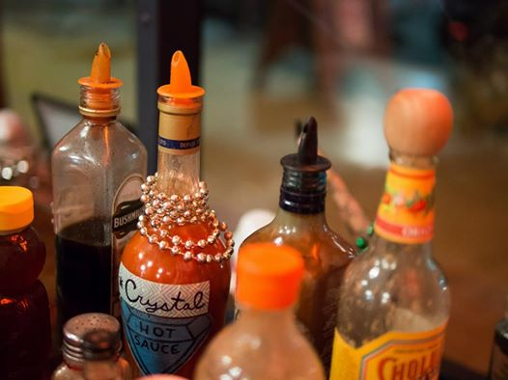

Top of Form
Like · · Share
Bottom of Form
Nancy White What are your standards?
January 30 at 7:31am · Like
Eugene Eric Kim My primary criteria is that the photo tell some story about my day. I did eat dinner at this restaurant, which I really enjoyed for a variety of reasons, and I also enjoyed the array of hot sauce bottles. But if I could make an image about what happened yesterday, this would be pretty low on my list.
On the other hand, this image evokes a lot of memories and feelings for me personally, largely because of the circumstances in which I took it. I look at it and am reminded of what it's not (which actually serves the purpose of reminding me of what happened), but I'm also reminded of one of the valuable reasons for doing a Photo-A-Day project: You're going to have good photos some days, not-so-good ones others, but the regularity, practice, and habit-building is a big part of the point. Even after only 29 days, I'm already finding myself being more mindful of moments, which in and of itself is such a wonderful benefit of this process. In the end, I'm proud that I didn't end up giving up yesterday, especially in the context of the workshop I led.
How are you enjoying your project, fellow traveler?
January 30 at 7:43am · Like · 2
January 30 at 7:43am · Like · 2
Nancy White Thanks, Eugene. That was really helpful for me to read, as I'm still very unclear about my own aims and criteria with the project. I think right now my baseline is low - get it done. I also have a tiny tablet and a cell phone as my camera, so I have to discover what makes a "good" picture on those devices. I do get intimidated by beautiful pictures by others (like you) and I have to shut off that voice.
I have enjoyed a) trying to be observant of images/moments and b) giving a tiny bit of context when I post. But it is still very emergent.
I am surprised how many people take the time to comment or like.
January 30 at 7:50am · Like
Eugene Eric Kim Nancy, even though we didn't plan it, knowing that you're doing this too has helped me _tremendously_. Several of your images have already inspired me. The other day, you posted this wonderful picture of your socks while sitting on the couch. I could feel your exhaustion from travel (which I knew about because of your project) and work, and your socks reminded me of your colorful personality.
It directly inspired my Day 28 photo the following day, which was just a picture of a freakin' clock! But while it may have been unremarkable on its own, it was a nice accompaniment to the story I ended up sharing, it revealed a bit about my personality, and it seemed to resonate with lots of folks. I also created a crude lighting effect by manipulating two desk lamps. I doubt that anyone else noticed that, but it serves as a happy indicator to me that I've become much more conscious about light.
I've also loved the emergent aspects of this project, which includes this exchange with you! I also love that you're taking photos with your phone and tablet.
Yesterday, after dinner, I went to Ici (an ice cream shop in Berkeley) for dessert with my sister, and I witnessed a wonderful moment that I wanted to capture. I immediately got frustrated, because I had forgotten to bring my camera inside, and I started thinking about how that moment could have represented so many things I was feeling that day.
The thing was, it was an extended moment. I could have tried capturing it with my phone. I did end up doing that, but I waited too long, because I was busy telling myself my phone wasn't good enough to capture the moment the way I wanted to. The thing was, my sister has an iPhone 6, which has a wonderful camera. Instead of whining to myself about all the things I couldn't do, I could have asked to borrow her phone, which is something a photographer friend of mine does all the time. Or I could have simply challenged myself to take an interesting picture with my phone.
You're showing me that you can tell great, interesting stories with a phone or tablet, and you're reminding me to embrace the spirit of the project and all of the unexpected things that are happening as a result. Please keep it up, Nancy! I'm loving the journal of your life, and I'm looking forward to hearing how your own learning evolves.
January 30 at 8:20am · Like · 2
f
Mariah Howard Wonderful dialog that reminds me of the power of art making and creative inspiration. Getting third hand benefits from the work both of you are doing. Blessings on your projects.
January 30 at 8:33am · Unlike · 4
Eugene Eric Kim Wow, Mariah, thank you! Coming from you, that means so much. I tell stories about your art — from your Groupaya birthday gift to your wonderful postcard after dinner one night to your amazing Right Now performances — and what it's meant to me all the time!
January 30 at 8:41am · Unlike · 2
Mariah Howard That's lovely to hear Eugene, and great timing.
January 30 at 8:48am · Unlike · 2
Nancy White That's funny, Eugene. Because when I saw the clock, it had resonance for the few pictures I did like the socks. Amazing!
January 30 at 9:08am · Like · 1
Nancy White Loving reading all of this. Off for a walking talk w Sue Wolff and I think this will flavor our conversation. And possibly today's photo. WONDERFUL!
January 30 at 9:10am · Like · 1
Eugene Eric Kim Thanks for the reminder, Holly! That totally counts too, yet I had completely forgotten that I had taken that. Speaking of our workshop, this is a good example of how my own scarcity mindset prevented me from seeing quite a bit of abundance! This whole thread has felt very abundant!
January 30 at 9:20am · Like
Nancy White Abundant and connected!
January 30 at 12:08pm · Like
Renee Fazzari Wow I loved reading this. And now I get your photo project far more clearly. Totally inspired!
January 30 at 1:54pm · Like
Nancy White Eugene, may I share this thread in a blog post? (I guess I should ask all the other posters too, but I'll not include you unless you say it is OK!)
13 mins · Like
Eugene Eric Kim Absolutely, Nancy!
12 mins · Like
Nancy White Thanks!
10 mins · Like

